|  |  |  |
| --- | --- | --- |
|  | ***i*RASD Journal of Educational Research**  **Volume 6, Number 2, 2025, Pages 01 - 08**  **Journal Homepage:** [**https://journals.internationalrasd.org/index.php/jer**](https://journals.internationalrasd.org/index.php/jer) |  |

**Vegan Cybercommunity in Thailand (VeCy)**

Wilawan Si1

1 Department of Environment Education, Faculty of Environment and Resource Studies, Mahasarakham University,44150, Thailand. Email: A0990373737@gmail.com

|  |  |
| --- | --- |
| **ARTICLE INFO** | **ABSTRACT** |
| ***Article History:***  Received: March 08, 2025  Revised: May 06, 2025  Accepted: May 07, 2025  Available Online: May 09, 2025 | Vegan is a person who does not eat any animal products. Vegan diet has benefits on weight reduction and risk of obesity that increases the risk of cardiovascular or heart disease. When Thai teenagers contribute to obesity from too much unhealthy foods. Vegan cyber community (Vecy) improve Vegan knowledge, performance, and satisfaction of Thai teenagers by experimental for 1 weeks with one group 66 samplings teenagers aged 20 in year 2025. There were five phases of research by ADDIE model. Phase 1, Analysis vegan contents; Phase 2, Design Vecy; Phase 3, Develop Vecy to access at htps://nadoon.online/indexeng2023.html; Phase 4, Implement Vegan Cyber community (Vecy); Phase 5, Evaluate Vegan Cyber community (Vecy). Approximately 90.91% of teenagers have knowledge product of vegetable such as Mushroom (Agaricus bisporus), Radish (Raphanus sativus), Kale (Brassica oleracea), Bean Sprout (Pisum sativum), Potato (Solanum tuberosum), Corn (Zea mays), Cucumber (Cucumis sativus), Bell pepper (Capsicum annuum), Lettuce (Lactuca sativa), Clover (Trifolium Pratense), Broccoli (Brassica oleracea var. italica), Marijuana (Cannabis sativa L.), Carrot (Daucus carota), Yard Long Bean (Vigna unguiculata var. sesquipedalis.), Green pea (Pisum sativum.), Black bean (Phaseolus mungo), Soybean (Glycine max). The fruits are Dragon Fruit (Hylocercus megalanthus), Apple (Malus domestica), Kiwi (Actinidia chinesis), Avocado (Persea americana Mill), Banana (Musa spp.), Honneydew Melon (Cucumismelo L. var. cantalpensis), Peach (Prunus persica), Orange (Citras Sinensis), Pomegranate (Punica granatum). Thai teenagers had positive satisfaction of Vegan cyber community (VeCy) to apply in daily. |
| ***Keywords:***  Vegan  Teenagers  Thailand  Online Community  Obesity  Health Information |
| **Funding:**  This research received no specific grant from any funding agency in the public, commercial, or not-for-profit sectors. |
| *© 2025 The Authors, Published by iRASD. This is an Open Access article under the Creative Common Attribution Non-Commercial 4.0* |

Corresponding Author's Email: A0990373737@gmail.com

1. **Introduction**

Obesity or overweight is a long-term disease when teenagers have too much body fat and increases the risk of cardiovascular or heart disease (Stanford Medicine Children’s Health, 2025). Vegan Consumption diet, vegetarians, plant-based reduces body fat and promote health from chronic diseases. cholesterol levels, blood pressure; heart disease, and many cancers Craig (2010); Najjar and Feresin (2019) including, plant-based diets can save the environment from animal agriculture (Desmond, Fewtrell, & Wells, 2024). In Thailand, young people become obesity or overweight because they have poor eating habits and aren’t active enough. The researcher tries to develop Vegan cybercommunity to reduce animal food consumption and shift towards plant-based diets vegan that have consumption of vegetables, fruits, cereals, nuts, to reduced diseases, such as ischemic heart diabetes, obesity, and many cancers. These activities can support concept of Health information that refers to any information that support the health of the population and the delivery of healthcare services. It includes data health service resources and activity, explanatory factors such as economic and sociodemographic information, and other related data such as social care and education (Health Information, 2025; Tegegne et al., 2022).

All over the world, healthy behaviors of teenagers gained popularity. The reason that Israel adolescents were overweight/obese due to dietary protein was mainly due to non-dairy animal protein (mostly meat and poultry). Therefore, they are to pay attention to the allergies to plant and dairy proteins intake (Chen, Zhao, & Chen, 2022) among over 50 million Americans (Renn & Rainville, 2019). In addition, agricultural entrepreneurs were also trained in food safety to enhance business skills of market and food safety practices (Crist & Canales, 2020). The Ukrainian participants of Kyiv, Ukraine, take part in a food safety short course (FSSC) to Enhance food safety knowledge, behaviors, attitudes, and skills in 6 months later, Whereas Brazilian and Spanish teens consume fruit during the COVID-19 lockdown. A younger Brazilian and Spanish population was more knowledgeable of the related variables regarding healthy diet would aid in setting the definitive measures in case of socially isolated situations (Victoria-Montesinos et al., 2023).

(Victoria-Montesinos et al., 2023) Spanish adolescents in central Spain (Castilla-La Mancha region), however, have a sweet, salty, and umami eating style of foods. Educational interventions, are proposed as potentially helpful to reduce food neophobias in adolescents (Del Campo et al., 2023). The lack of breakfast, consumption of sweets and high level of rice and pasta may result in the enhancement of feelings, behavior, hyperactivity and peer related issues in Spanish Adolescents. To enhance the psychosocial health issues of adolescents and avert the mental health disorders they might encounter later in life (depression, stress, or anxiety), these groups are to consume fruit, nut, and legume (Alfaro-González et al., 2023). In addition to that, parents influence Spanish teenagers to have a healthy lifestyle. (Del Campo et al., 2023). The association between lifestyle and diet quality and physical activity of parents is in. (2023). Lots of Romanian and Spanish teens do not have an adequate breakfast on a daily basis. Spanish breakfast habits include bread, cereals, cookies, juice and olive oil. Romanian are cereals, juices, biscuits, and jam (Soriano-Ayala & Cala, 2015).

Improving healthy behavior with training were conducted generally. Online Food Safety Training Programs were trained instructors with 3 modules. More than 85% of the participants responded positively (Neal Jr et al., 2011), Over 50 million Americans have a food allergy to one or more foods (Renn & Rainville, 2019). Besides, the food safety training was applied for agricultural entrepreneurs to improve business skills of market and food safety practices (Crist & Canales, 2020). Ukrainian Participants of Kyiv, Ukraine, attend Food Safety Short Course (FSSC) to Improves food safety knowledge, behaviors, attitudes, and skills of. 6 months later, the participants' food safety attitude and behavior were positively enhanced the global safety of the food supply (Ercan Oruc et al., 2020). Finally, Vegan Cybercommunity for teenagers in Thailand will research for enhance vegan behavior among Thai adolescents. Since, most teenagers became obesity because of junk food consumption behavior and ignore of healthy lifestyle. Therefore, Thai teenagers should be encouraged the vegan benefits of consume grains, vegetables, fruits by health information with digital Era.

1. **Literature Review**

Food is a basic of human need for healthy growth and development in the lives of individual, household, communities, nations, and globally. Then, food associates with healthy eating in every day. Slater (2014); Vidgen (2016) food literacy concerns vegan since vegan is a person who does not eat any animal products such as meat, milk or eggs (Cambridge University Press, 2023; Press, 2023) but American Dietetic Association planned vegan diets are healthful, nutritionally adequate, and prevention diseases (Craig, 2010). Especially. A vegan diet has higher in fiber and lower in cholesterol. It can be healthy and some studies find benefits of a vegan diet such as reducing risk of heart disease by lowering cholesterol levels, and reduces the risk of cancer (Zurich. 2023.) Finally, this vegan concept begins in Thailand. In Thailand, young people become obesity or overweight and aren’t active enough because they have poor eating habits of junk food, fast food, bag snacks, crispy snacks among teenagers in Thailand (Lovirakorn, 2010; Sangraksa, 2010). Obesity or overweight is a long-term disease when teenagers has too much body fat and increases the risk of cardiovascular or heart disease (Según, 2025). Vegan Consumption diet, vegetarians, plant-based reduces body fat and promote health from chronic diseases. cholesterol levels, blood pressure; heart disease, and many cancers (Craig, 2010; Najjar & Feresin, 2019).

Healthy behaviors of teenagers became popular all around the world. Israeli adolescents had overweight/obesity because of dietary protein, predominately from non-dairy animal sources (mostly meat and poultry). So, they should observe for plant and dairy protein consumption. Whereas Brazilian and Spanish adolescents eat fruit during the COVID-19 lockdown. The young Brazilian and Spanish community was more familiar with the related elements concerning the healthy diet that might assist in setting the tangible measures in case of the social isolation instances (Victoria-Montesinos et al., 2023). Yet, Spanish teenagers of the central part of Spain (Castilla-La Mancha region) possess eating habits of sweet, salty, and umami preferences of food. Educational interventions, are proposed to be the helpful approaches to reduce food neophobias among teenagers (Del Campo et al., 2023). Spanish Adolescents are foregoing breakfast, sweets, and excessive consumption of rice and pasta may elevate emotions, behavior, hyperactivity, and peer problems. The groups are to consume fruit, nut, and legume to address the psychosocial issues of adolescents and avoid future psychopathological problems, including depression, stress, or anxiety (Alfaro-González et al., 2023).

Health information refers to any Vegan information that support activities to improve the health of the population and the delivery of healthcare services. It includes data health service resources and activity, explanatory factors such as economic and sociodemographic information, and other related data such as social care and education. Tegegne et al. (2022) Health Information (2025). Vegan cybercommunity relate Health information use that refers to the application of health-related Vegan data to inform decisions and actions in healthcare. This can range from individual health management to broader public health. It involves accessing, analyzing, and improve health outcomes, (Ettel et al., 2012). Improving healthy behavior with online training with cyber community were conducted generally because adolescent Internet use grew exponentially in the last decade The cyber community or Vecy contained instructors with 8 modules and the participants have attitude and behavior were positively enhanced the healthy diet (Ercan Oruc et al., 2020).

1. **Method**

Vegan cyber community (Vecy) improve Vegan knowledge, performance, and satisfaction of Thai teenagers after training with 15 weeks. There was experimental with one group samplings. The sampling was 66 teenagers aged 20 as environment undergraduate students at faculty of environment and resource studies at Mahasarakham University, Thailand. The tools were the vegan exercise, the vegan tests, and the interview attitude questionnaire. There are five phases of research by ADDIE model. Phase 1, Analysis vegan contents; Phase 2, Design Vegan Cyber community (Vecy); Phase 3, Develop Vegan Cyber community (Vecy) that can access at https://nadoon.online/indexeng2023.html.; Phase 4, Implement Vegan Cyber community (Vecy); Phase 5, Evaluate Vegan Cyber community (Vecy)

1. **Finding**

The result found that Vegan cybercommunities was effective to improve Vegan knowledge and performance of teenagers after training.

* 1. Modules of Vecy Cybercommunity

The results of Table1 provided information on the 8 modules in Vecy cyber community for teenagers. The modules presented vegan concepts such as name, benefit, nutrition, amount of eating per day plantation.

Table 1: Modules of Vecy Cybercommunity

|  |  |  |  |
| --- | --- | --- | --- |
| Week | Vegan Description | Week | Vegan Description |
| 1 | Name | 5 | Plantation |
| 2 | Benefit | 6 | Scientific name |
| 3 | Nutrition | 7 | Picture |
| 4 | Amount for eating per day | 8 | Multimedia |

**4.2. Access to Vegan cyber community (Vecy)**

The results of Figure 1presented the front page of Vegan cyber community (Vecy). The results of Figure.1 Thai teenagers can access by self- directed training at https://nadoon.online/indexeng2023.html. There are various vegan activities such as reading, creating and There is a vegan space of participation, and discussion.

**Figure 1: Access to Vegan cyber community (Vecy)**

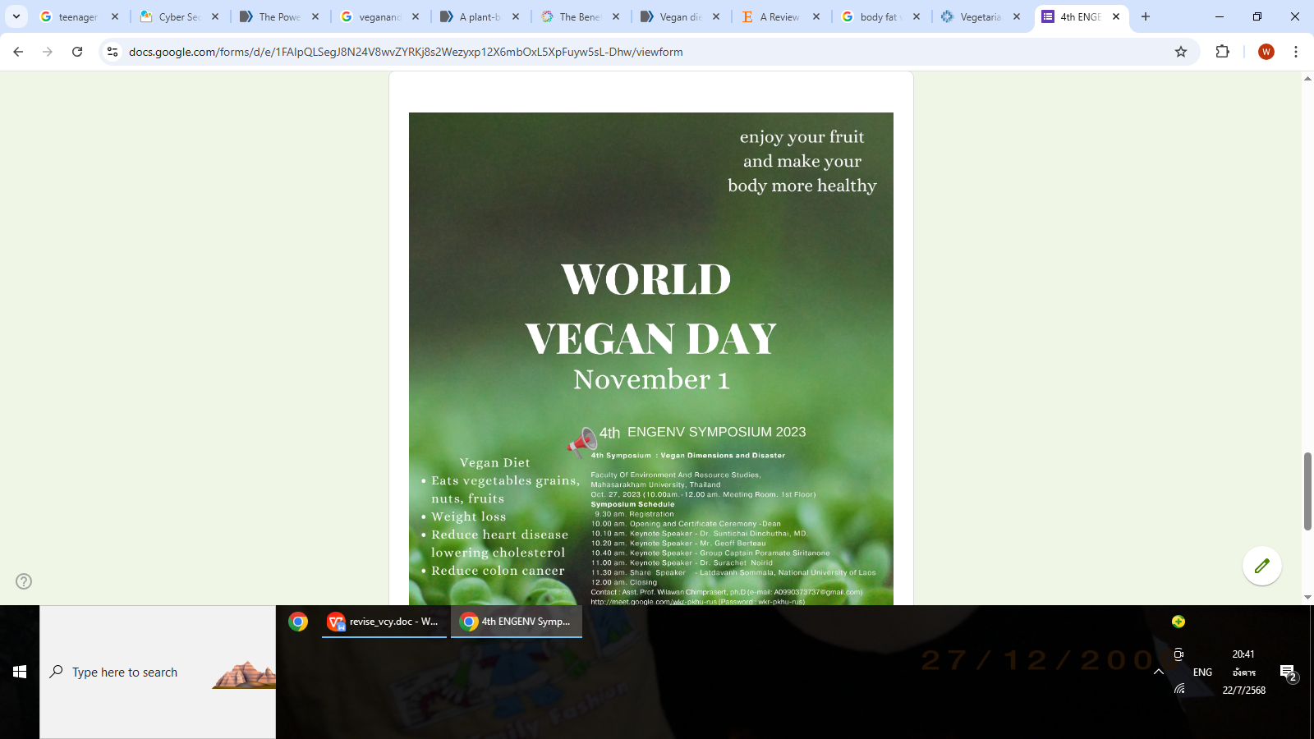

***Source:*** https://nadoon.online/indexeng2023.html

**4.3. Evaluation of Vegan cyber community (Vecy)**

**4.3.1. Vegan product Knowledge of teenager**

From Evaluation of Vegan cyber community (Vecy). Cyber community can improve knowledge of teenagers about Vegan product and vegan performance. Approximately 90.91% of teenagers have knowledge product of vegetable (Table 1)

**Table 1: Vegan product Knowledge of teenager (N = 66)**

|  |  |  |
| --- | --- | --- |
| **Vegan** | **frequency** | **percentage** |
| Fruit | 6 | 9.09 |
| Vegetable | 60 | 90.91 |
| Total | 66 | 100 |

**4.3.2. Vegan description Knowledge of teenager**

From Evaluation of Vegan cybercommunity (Vecy), Cybercommunity can improve knowledge of teenagers about Vegan descriptions; name, benefit, nutrition, amount for eating, scientific name plantation as (Table 2).

**Table 2: Vegan Description Knowledge of teenager (N = 66)**

|  |  |  |  |  |  |
| --- | --- | --- | --- | --- | --- |
| **vegan name** | **Benefit** | **Nutrition** | **Eating/**  **day** | **Plantation** | **Scientific name** |
| Dragon Fruit | Skin | C | 1 fruit | America | *Hylocercus megalanthus* |
| Apple | Teeth | Fiber, C | 1 fruit | Soviet Union, Japan, China, New Zealand, Australia | *Malus domestica* |
| Kiwi | Skin | C | 3 fruits | New Zealand | *Actinidia chinesis* |
| Avocado | Heart | Fiber, C | 1 fruit | Mexico, Thailand | Persea americana Mill |
| Banana | Stomach | C | 2 fruits | Thailand | *Musa spp.* |
| Honeydew Melon | Skin | C | 500 g | France, Algeria, Spain | *Cucumismelo L. var. cantalpensis* |
| Peach | Skin, intestine | A, C, E, K | 2-3 fruits | Thailand | *Prunus persica* |
| Orange | Eyes | C | 2-3 fruits | Thailand | *Citras Sinensis* |
| Pomegranate | Blood, bone, liver | B6, B12, C | 1fruit | India | *Punica granatum* |
| Mushroom | Brain | B, D | 0.60-1g | China, Japan, USA | *Agaricus bisporus* |
| Radish | kidney | calcium | 100 g | Egypt, Thailand, Japan | *Raphanus sativus* |
| Kale | Heart, Eye | Protein, C, K, calcium | 100 g | Italy, Thailand | *Brassica oleracea* |
| Bean Sprout | Heart | A, C, B, E, iron, calcium | 100 g | Thailand | *Pisum sativum* |
| Potato | Brain | Iron, C | 1 potato | Mexico, Chile, Bolivia, Peru | Solanum tuberosum |
| Corn | Eyes | Carbo | 1 corn | United State | *Zea mays* |
| Cucumber | Knee, skin | Calcium, Iron, C | 100 g | India | *Cucumis sativus* |
| Bell pepper | Blood, eye, intestine | Potassium, C | 100 g | Thailand | *Capsicum annuum* |
| Lettuce | Blood | Carbo,calcium | 400 g | Europe, Asia | Lactuca sativa |
| Clover | Eyes, Mouth | C | 100 g | Thailand, Japan, Indonesia, Australia | *Trifolium Pratense* |
| Broccoli | Eyes | C, A, K, Folate | 400 g | Italy | *Brassica oleracea var. italica* |
| Marijuana | Blood, bone | C | 1 drop | Thailand | *Cannabis sativa L.* |
| Carrot | Hair, bone, Skin | Fiber, A, C, K | 100 g | Thailand | *Daucus carota* |
| Yard Long Bean | Bone, Teeth | Protein, C Carbohydrate, | 100 g | China, India | *Vigna unguiculata var. sesquipedalis.* |
| Green pea | Heart, eye | Calcium, Mg | 100 g | Ethiopia, Thailand Mediterranean | *Pisum sativum.* |
| Black bean | Eyes | Protein, fiber | 100 g | Brazil | *Phaseolus mungo* |
| Soybean | Bone, skin | Protein | 0.81 g | Brazil, Thailand | *Glycine max* |

**4.3.3. Vegan Performance of teenager**

From performance Evaluation of Vegan cyber community (Vecy). Cyber community can improve Vegan performance of teenagers by creating vegan multimedia to distribute vegan knowledge in communities as Figure 2.

**Figure 2: Vegan *Performance of Vegan of teenager (N = 66)***

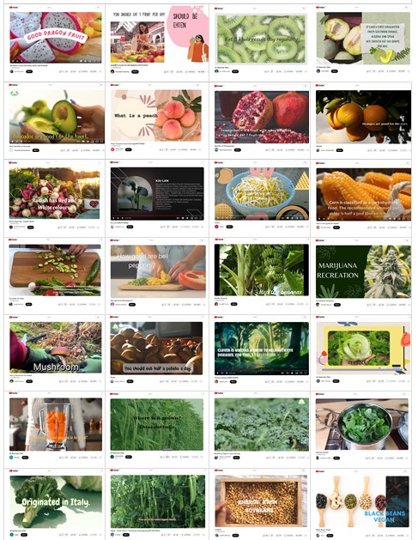

**4.3.4. Satisfaction of Vegan cyber community (Vecy)**

By interview with 9 Thai teenagers *(N = 66)* found that they had positive satisfaction of *Vegan cyber community (Vecy) to apply in daily after training as* (Figure 3).

**Figure 3: Satisfaction of Vegan cyber community (Vecy)**

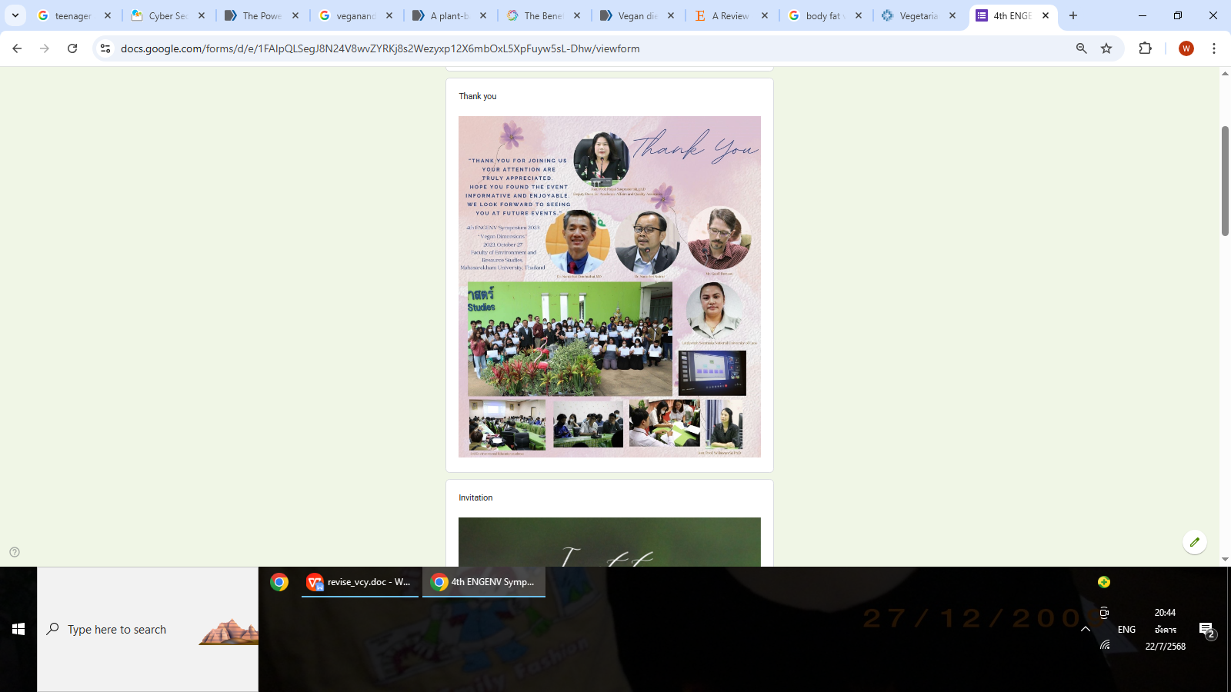

1. **Conclusions**

Vegan refers to an individual who is not a consumer of animal products. There are numerous environmental factors that cause obesity in Thai adolescents. As an illustration, teenagers may be over exposed to unhealthy foods and under exposed to healthy foods, they might experience sleep disorder Vegan diet has advantages in weight loss and obesity risk. Vegan cyber community (VeCy) enhance Vegan knowledge, performance, and satisfaction of Thai teenagers post-training in 15 weeks. There was experimental with one group samplings for 66 teenagers aged 20 There were five phases of research by ADDIE model. Phase 1, Analysis vegan contents; Phase 2, Design Vegan Cyber community (VeCy); Phase 3, Develop Vegan Cyber community (VeCy) that can access at https://nadoon.online/indexeng2023.html.; Phase 4, Implement Vegan Cyber community (VeCy); Phase 5, Evaluate Vegan Cyber community (VeCy).

Approximately 90.91% of teenager’s year 2025, they have knowledge product of vegetable. *Vegan cyber community (Vcy)* can improve new generation of teenagers of vegan food from vegetables, and fruits, There were 14 named of vegetables as Mushroom *(Agaricus bisporus),* Radish *(Raphanus sativus),* Kale (*Brassica oleracea*), Bean Sprout *(Pisum sativum),* Potato (Solanum tuberosum), Corn (*Zea mays),* Cucumber *(Cucumis sativus)*, Bell pepper *(Capsicum annuum),* Lettuce (Lactuca *sativa*), Clover *(Trifolium Pratense),* Broccoli *(Brassica oleracea var. italica),* Marijuana *(Cannabis sativa L.),* Carrot (*Daucus carota),* Yard Long Bean (*Vigna unguiculata var. sesquipedalis.),* Green pea (*Pisum sativum.)*. There were 8 named of fruits as Dragon Fruit (*Hylocercus megalanthus),* Apple (*Malus domestica), Kiwi* (*Actinidia chinesis),* Avocado (Persea americana *Mill*), Banana *(Musa spp.),* Honneydew Melon (*Cucumismelo L. var. cantalpensis),* Peach (*Prunus persica*), Orange (*Citras Sinensis),* Pomegranate (*Punica granatum*). There were 2 named of grains as Black bean (*Phaseolus mungo),* Soybean (*Glycine max*).

Teenage healthy behaviors were popular everywhere in the world. The overweight/obesity was due to the dietary protein contained in animal sources (mostly meat) by Israeli adolescents. Therefore, they ought to monitor plant (Chen, Zhao, & Chen, 2022). Spanish and Brazilian teens consume fruit during the coronavirus lockdown. They were more knowledgeable on the related factors regarding healthy diet under the circumstances of social isolation. (Victoria-Montesinos et al., 2023). Spanish adolescents from central Spain (Castilla–La Mancha region) have eating styles of sweet, salty, and umami tastes of foods. They have educational activities, to suggest as useful methods to decrease food their neophobias (Del Campo et al., 2023). Spanish Adolescents are skipping breakfast, and intake of sweets, rice and pasta that could increase emotion, conduct, hyperactivity, and peer problems. They should intake fruit, nut, or improves adolescents’ psychosocial health problems and prevent future mental disorders such as depression, stress, or anxiety (Sofía Alfaro-González, Miriam Garrido-Miguel, Vicente Martínez-Vizcaíno, and José Francisco).

**Acknowledgment**

Thank you Mahasarakham University for material support.

**Conflicts of Interest**

The author has no relevant competing interest to declare pertaining to the content of this article

**References**

Alfaro-González, S., Garrido-Miguel, M., Martínez-Vizcaíno, V., & López-Gil, J. F. (2023). Mediterranean Dietary Pattern and Psychosocial Health Problems in Spanish Adolescents: The EHDLA Study. *Nutrients*, *15*(13), 2905. <https://doi.org/10.3390/nu15132905>

Cambridge University Press, c. (2023). <https://dictionary.cambridge.org/dictionary/english/vegan>. Accessed 1 Oct 2023.

Chen, P., Zhao, Y., & Chen, Y. (2022). A vegan diet improves insulin resistance in individuals with obesity: a systematic review and meta-analysis. *Diabetology & Metabolic Syndrome*, *14*(1), 114. <https://doi.org/10.1186/s13098-022-00879-w>

Craig, W. J. (2010). Nutrition Concerns and Health Effects of Vegetarian Diets. *Nutrition in Clinical Practice*, *25*(6), 613-620. <https://doi.org/10.1177/0884533610385707>

Crist, C., & Canales, E. (2020). Multidisciplinary Program Approach to Building Food and Business Skills for Agricultural Entrepreneurs. *Journal of Extension*, *58*(3). <https://doi.org/10.34068/joe.58.03.12>

Del Campo, C., Bouzas, C., Monserrat-Mesquida, M., & Tur, J. A. (2023). Assessing Food Preferences and Neophobias among Spanish Adolescents from Castilla–La Mancha. *Foods*, *12*(20), 3717. <https://doi.org/10.3390/foods12203717>

Desmond, M. A., Fewtrell, M. S., & Wells, J. C. K. (2024). Plant-Based Diets in Children: Secular Trends, Health Outcomes, and a Roadmap for Urgent Practice Recommendations and Research—A Systematic Review. *Nutrients*, *16*(5), 723. <https://doi.org/10.3390/nu16050723>

Ercan Oruc, D., Pokharel, S., Anantheswaran, R. C., Bucknavage, M. W., Gourama, H., Shanina, O., & Cutter, C. N. (2020). A comprehensive food safety short course (FSSC) improves food safety knowledge, behaviors, attitudes, and skills of Ukrainian participants. *Journal of Food Science Education*, *19*(4), 263-277. <https://doi.org/10.1111/1541-4329.12208>

Ettel, G., Nathanson, I., Ettel, D., Wilson, C., & Meola, P. (2012). How Do Adolescents Access Health Information? And Do They Ask Their Physicians? *The Permanente Journal*, *16*(1), 35-38. <https://doi.org/10.7812/TPP/11-125>

Health Information, H. (2025). <https://www.sciencedirect.com/topics/computer-science/health-information>.

Lovirakorn, I. K. a. S. (2010). The nutritional status, food consumption and health related behavior of students majoring in food and nutrition of Khon Kaen Vocational College. *KKU Journal for Public Health Research*, 29-36.

Najjar, R. S., & Feresin, R. G. (2019). Plant-Based Diets in the Reduction of Body Fat: Physiological Effects and Biochemical Insights. *Nutrients*, *11*(11), 2712. <https://doi.org/10.3390/nu11112712>

Neal Jr, J. A., Murphy, C. A., Crandall, P. G., O’Bryan, C. A., Keifer, E., & Ricke, S. C. (2011). Development of an Evaluation Tool for Online Food Safety Training Programs. *Journal of Food Science Education*, *10*(1), 9-12. <https://doi.org/10.1111/j.1541-4329.2010.00112.x>

Press, O. U. (2023). Vegan. <https://www.oxfordlearnersdictionaries.com/definition/english/vegan_1?q=vegan>

Renn, L., & Rainville, A. J. (2019). School nutrition training needs regarding food sensitivities and food trends.

Sangraksa, W. K.-u. a. N. (2010). Junk food consumption of bachelor degree university students in Nakhnopathom province : case study Kasetsart university and Silpakorn university. *Silpakorn Educational Research Journal*, 114-125. <https://educ.su.ac.th/2013/images/stories/020755_02.pdf>

Según, J. C. B.-M., Idoia Labayen, Augusto G. Zapico, Jesús Sánchez- Gómez , Stanford Medicine Children’s Health. (2025). <https://www.stanfordchildrens.org/en/topic/default?id=obesity-in-teens-90-P01627>

Slater, J. (2014). Food literacy: bridging the gap between food, nutrition and well-being. *Sustainable well-being: concepts, issues, and educational practices. ESWB Press, Winnipeg*.

Soriano-Ayala, E., & Cala, V. C. (2015). A Comparative Study of Breakfast Habits of Romanian and Spanish Adolescents Enrolled in Southern Spain Schools1. *Practice and Theory in Systems of Education*, *10*(3), 276-284. <https://doi.org/10.1515/ptse-2015-0026>

Tegegne, M. D., Yilma, T. M., Melaku, M. S., Wubante, S. M., Demsash, A. W., & Walle, A. D. (2022). Health information seeking and its associated factors in Ethiopia: Systematic review and meta-analysis. *Informatics in Medicine Unlocked*, *31*, 100980. <https://doi.org/10.1016/j.imu.2022.100980>

Victoria-Montesinos, D., Tárraga-Marcos, A., Brazo-Sayavera, J., Jiménez-López, E., Gutiérrez-Espinoza, H., Panisello Royo, J. M., Tárraga-López, P. J., & López-Gil, J. F. (2023). Adherence to the Mediterranean Diet and Health-Related Quality of Life during the COVID-19 Lockdown: A Cross-Sectional Study including Preschoolers, Children, and Adolescents from Brazil and Spain. *Nutrients*, *15*(3), 677. <https://doi.org/10.3390/nu15030677>

Vidgen, H. (2016). *Food Literacy* (0 ed.). Routledge.